

P R O P O S A L

8D7N Brompton Experience Cycling Tour:
Denmark & Sweden
(Recce Tour)

2026

Prepared By

Eugene Lim
Director

18 May 2026
(Last Updated)

Business Registration Number: 201115610G
Camp High Achievers Pte Ltd
(BROMPTON EXPERIENCES)
TA Licence Number: 01748

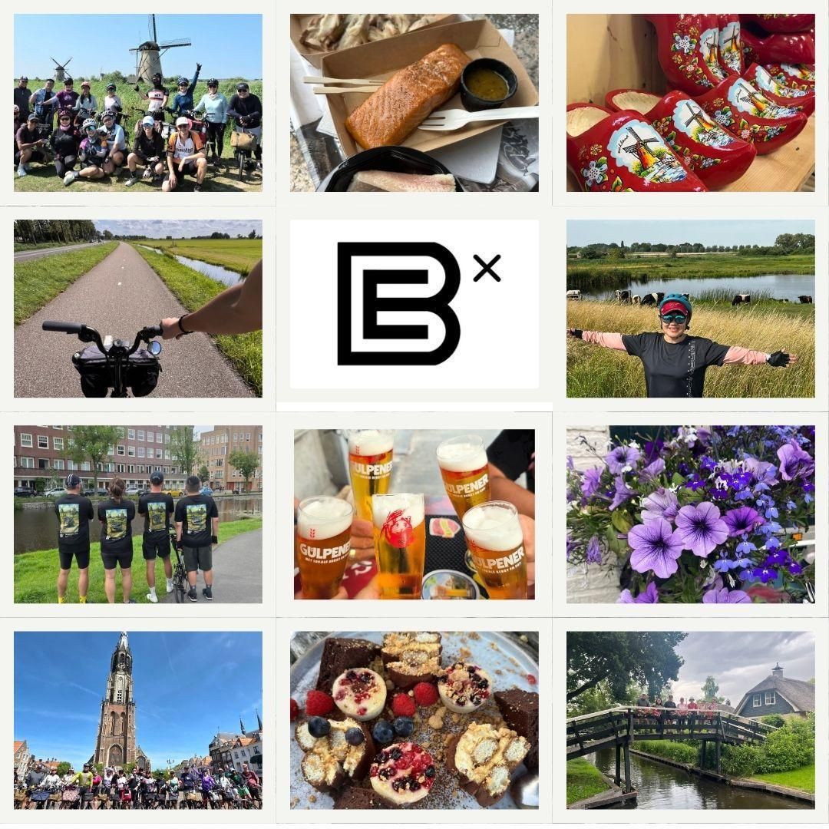

April - June (Spring Summer) | April welcomes the start of tulip season, with temperatures ranging from 6°C to 14°C. You’ll experience cool mornings and mild afternoons, often with a mix of sunshine and light showers. A light jacket, umbrella, and layered clothing are essential for this month. (8pm sunset)  May brings longer daylight hours and more stable weather. Temperatures average between 9°C and 18°C. Gardens and parks are in full bloom, and it’s a fantastic time for cycling and outdoor activities. You’ll still want to carry a light raincoat—occasional spring showers can still surprise you. (8.30pm sunset)  June, early summer sets in with warmer days (12°C to 21°C on average), lush green landscapes, and generally more sunshine. Rain is still possible, but less frequent, and you’ll enjoy ideal conditions for touring cities, countryside rides, and canal-side strolls. (9.30pm sunset)
Sep - Oct (Authum) | September still carries the warmth of late summer, with average temperatures ranging from 12°C to 20°C. It’s a lovely time for cycling along canals, visiting outdoor markets, and enjoying café terraces. While the days are generally mild and pleasant, expect the occasional rain shower—so a light waterproof jacket is a smart companion. (7.15 pm Sunset)  By October, autumn is in full swing. Temperatures drop to around 8°C to 15°C, and the Dutch landscape transforms into a canvas of reds, oranges, and yellows.Rain becomes more frequent, so good layering and a windproof jacket are advisable. (6.30 pm Sunset)

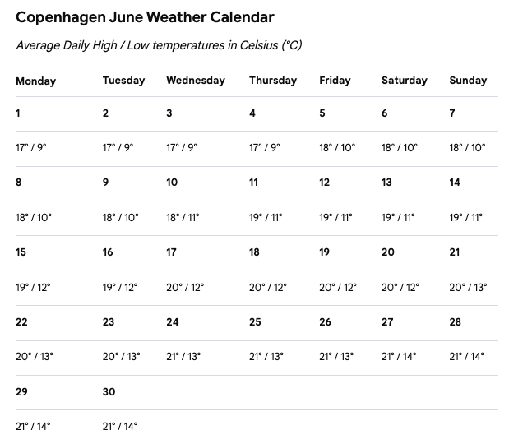

Detailed Itinerary

Day | Details | Km | Transfer | Remarks
1  June 12 | - 0710 - Arrive at Copenhagen Airport  - 0930 - Transfer from Airport to Copenhagen Central Station to intercity train to Lund  - 1030 - Copenhagen to Lund  - 1130 - Check-in to hotel  - 1230 - Lunch  - 1430 - Orientation on how to cycle in Sweden. Road safety ride around Lund (15km)  - 1930 - Dinner | 60km | 9 Seater Passenger Vehicle +  Logistics Safety Vehicle | Load bikes in support vehicle  City : Lund  Hotel: Scanic Star  https://www.scandichotels.com/en/hotels/scandic-star-lund#offers
2  June 13 | - 0730 - Breakfast in the Hotel  - 0830 - Day trip: Lund to Malmö  - Ridesborg Park  - Limhamm Harbour  - 1230 - Lunch in Sydkutleden (Giant Shrimp Sandwiches)  - 1400 - Malmöhus Castle  - 1700 - Return to Lund  - 1930 - Dinner at Matrummet | 40km | 9 Seater Passenger Vehicle +  Logistics Safety Vehicle | Malmöhus Castle  https://malmo.se/Uppleva-och-gora/Konst-och-museer/Malmo-museum/Besok-Malmo-museum/Vara-byggnader/Slottet/Malmohus-slott.html  Matrummet: https://www.matrummetilund.se/
3  June 14 | - 0700 - Breakfast in the Hotel  - 0900 - Coastal Ride to Helsingborg  - 1300 - Lunch: Pumphuset Borstahusen or Kvarteret Erikstorp, Svenholm  - 1500 - Continue to Helsingborg  - 1700 - Check into hotel: Clarion Hotel See U  - 1800 - Rest & Leisure/Walking Tour of Kärnan (The Keep), Helsingborg Castle  - 1930 - Dinner at Hamnkrogen or Thai Corner | 40 km | 9 Seater Passenger Vehicle +  Logistics Safety Vehicle | City: Helsingborg  Hotel: Clarion Hotel & Congress See U
4  June 15 | - 0700 - Breakfast in the Hotel  - 0900 - Cycle the Höganäs Harbor and Bathhouse – Viken Harbour-Christians Fishause Loop from Maria  - 1300 - Lunch at Hamnplan 9 near Vikens  - 1500 - Cycle loop back to Helsingborg  - 1700 - Rest & Leisure  - 1930 - Dinner at Brasseiet Helsingborg | 55 km | 9 Seater Passenger Vehicle +  Logistics Safety Vehicle | Viken Harbour-Christians Fishause Loop from Maria  https://www.komoot.com/smarttour/9672208
5  June 16 | - 0730 - Breakfast at hotel  - 0900 - Cycle to Ferry terminal  - 1000 - Ferry to Helsingør DK  - 1100 - Cycle to Kronborg Castle  - 1300 - Lunch: Ciao Ciao  - 1700 - Check into Sauntehus Castle Hotel  - 1930 - Dinner at Castle | 55 km | 9 Seater Passenger Vehicle +  Logistics Safety Vehicle | Sauntehus Castle Hotel  https://sauntehus.slotshotel.dk/
6  June 17 | - 0700 - Breakfast in the Hotel  - 0900 - Check out and cycle to Copenhagen  - 1200 - Lunch: Haglodt (Scandi & Indian) or Saffron Indian or Restaurant Thorvald (Seafood)  - 1600 - Check into hotel: Scandi Spectrum  - 1700 - Rest & Leisure / Walking Tour  - 1930 - Dinner at Pate Pate (French, Spanish, Moroccan) | 55 km | 9 Seater Passenger Vehicle +  Logistics Safety Vehicle | Scandi Spectrum CPH  https://www.scandichotels.com/en/hotels/scandic-spectrum?utm_source=google&utm_medium=organic&utm_campaign=gmb&utm_content=spectrum
7  June 18 | - 0700 - Breakfast in the Hotel  - 0900 - Cycle Copenhagen’s Cherry Route  - 1300 - Lunch  - 1500 - Frederiksberg Castle  - 1700 - Rest & Leisure / Walking Tour  - 1930 - Dinner at Kødbyens Fiskebar | 30 km | 9 Seater Passenger Vehicle +  Logistics Safety Vehicle | Cherry Route:  http://cyclingincopenhagen.com/cherry-loop/
8  June 19 | - 0830 - Check and Airport Transfer | Total  285km | 9 Seater Passenger Vehicle +  Logistics Safety Vehicle

* Cycling plans are subject to weather and safety conditions. CHA may alter cycling routes with the objective of improving your cycling experience.

For further programme details please refer to:
Digital Brompton Cycling Tour - Denmark/Sweden : Marketing Brochure ( Coming Soon )

Summary Of Transfers

Day | Date / Day | Movement | Transfers | Remarks
01 |  | Train: Copenhagen to Lund  Luggage only; bikes travel by Logistics vehicle  Hotel: Scandic Star, Lund | 9 Seater Passenger Vehicle  Logistics Safety Vehicle | Hotel: Scanic Star Lund  https://www.scandichotels.com/en/hotels/scandic-star-lund#offers
02 |  | Cycle: Lund to Malmö day trip | 9 Seater Passenger Vehicle  Logistics Safety Vehicle | Hotel: Scanic Star Lund  Malmöhus Castle  https://malmo.se/Uppleva-och-gora/Konst-och-museer/Malmo-museum/Besok-Malmo-museum/Vara-byggnader/Slottet/Malmohus-slott.html
03 |  | Cycle: Lund to Helsingborg | 9 Seater Passenger Vehicle  Logistics Safety Vehicle | Hotel: Clarion Hotel Helsingborg  https://www.strawberry.dk/hoteller/danmark/kastrup-lufthavn/clarion-hotel-copenhagen-airport/?utm_campaign=gmb-listing&utm_medium=organic&utm_source=google
04 |  | Cycle: Viken Harbour-Christians Fishause Loop (Helsingborg) | 9 Seater Passenger Vehicle  Logistics Safety Vehicle | Hotel: Clarion Hotel Helsingborg
05 |  | Cycle: from Helsingborg, SE to Helsingør, DK  Ferry across the channel | 9 Seater Passenger Vehicle  Logistics Safety Vehicle | Hotel: Sauntehus Castle Hotel  https://sauntehus.slotshotel.dk/
06 |  | Cycle Helsingör to Copenhagen | 9 Seater Passenger Vehicle  Logistics Safety Vehicle | Hotel: Scandic Spectrum  https://www.scandichotels.com/en/hotels/scandic-spectrum?utm_source=google&utm_medium=organic&utm_campaign=gmb&utm_content=spectrum
07 |  | Cycle Copenhagen Cherry Loop | 9 Seater Passenger Vehicle  Logistics Safety Vehicle | Hotel: Scandic Spectrum  https://www.scandichotels.com/en/hotels/scandic-spectrum?utm_source=google&utm_medium=organic&utm_campaign=gmb&utm_content=spectrum
08 |  | Hotel to Copenhagen International airport. | No Support Vehicle | Hotel: Scandic Spectrum  https://www.scandichotels.com/en/hotels/scandic-spectrum?utm_source=google&utm_medium=organic&utm_campaign=gmb&utm_content=spectrum

Flight Schedules

With respect to this tour we recommend that you procure your flight tickets early according to the above schedule.
- Please secure your tickets early to redeem miles points.
- Please ensure that min 30kg of allowable luggage to facilitate Brompton and travel luggage.
- CHA will be using the following flight schedule should you wish to accompany the team.
- You may choose other flight arrangements.

Proposed Flight Schedule
SQ 352 Singapore (SIN) To Copenhagen (CPH)
Dep June 12, 0005, arr June 12, 0710

SQ 351 Copenhagen (CPH) to Singapore (SIN)
Dep June 19, 1155, arr June 20, 0625

Participants who wish to extend their stay will be required to secure their own individual Hotel to Airport transfer.

General Programme Details

Programme Title | 8D7N Denmark Brompton Tour
Programme Duration | 8D7N
Proposed Tour Dates | 12 - 19 June 2026 (Recce Tour)
Tour Venue | Denmark : Copenhagen, Helsingor; Sweden: Lund, Malmö, Helsingborg
Programme Fee per Person | € 3,800 Nett SGD $5,800 (until 15 March 2026)  Package rate per pax based on twin share  € 4,600 Nett SGD $6,900(until 15 March 2026)  Package rate 1 pax based on single room  Luxury Canal Cruise Supplement € 80 - Inc for early bird 1 Jan 2026 Signup  Airport Transfer Supplement € 60 per trip
Airline | Self Secured
Accommodation | 3 - 4 star business hotels ( 7 Nights )
Meals | 6 Breakfast, 7 Lunch, 7 Dinners  Alcohol excluded (Optional add on at each meal)
Laundry | NA (Excluded) - Cabin bag when traveling out of Denmark/Sweden For 5 Days
Specialists Manpower | - 2 Brompton Tour Specialists Guides (Singapore)  - 1 Local Support / Transport Driver
Safety Measures & Bike Care | - Basic First-Aider  - Riding Instructor And Road Safety  - Mobile Brompton Mechanic Support (Essentials)  - Support vehicle to accommodate up to 4 passengers each should they be unable to ride
Equipment (Optional) | Brompton Rental from Singapore ($300) for trip duration. Self Carry.  Brompton Rental from Denmark ($300) for tour duration only.
Transportation | - 1 Equipment Safety Vehicle (3-person + Brompton equipment capacity)  - 60% full transport capabilities for short distance cyclists.
Insurance Coverage | Self Secured
Others | Visa application fees excluded. ($38) Visa administration for non-Singaporean passport holders ($150).

Required Items (See Packing List)

- Brompton Bicycle + Travel Case + Helmet + Front Carrier Bag
- Brompton Cover / Train
- Front and Rear Lights
- 2 Spare Inner Tubes (Provided)
Excluded From Tour Pricing

Items | SGD
Air ticket (Economy) | $1,800 - $2,200
Visa Fee (where applicable for non SG passport holders) | € 80
Travel Insurance  (with Covid-19 coverage) | $85.00
Airport to Hotel transfer other than the designated tour schedule dates | € 60 / one way

Acceptance Letter

Programme Title | 7D6N Denmark & Sweden Brompton Cycling Tour
Programme Duration | 8 Days 7 Nights
Proposed Tour Dates | 12 - 19 June 2026
Venue | Denmark : Copenhagen, Helsingor; Sweden: Lund, Malmö, Helsingborg
Programme Fee per Person  (Please Select Preferred Package) | € 3,800 Nett SGD $5,800 (until 15 March 2026)  Package rate per pax based on twin share  € 4,600 Nett SGD $6,900 (until 15 March 2026)  Package rate 1 pax based on single room  Airport Transfer Supplement € 60 per trip

I, __________________________________________, hereby confirm the above mentioned and verified that i have
(Name/ NRIC (last 4 digits)
read and understood the Terms and Conditions as set out in this proposal.

Signature |  | Date |  | Stamp (if Organisation)

In case of emergency, please contact

Name of person: ________________________________ Contact no.: ________________

I, agree to participate in the Cycling Experience of my own free will and volition, and am aware of the risks involved outdoor cycling and in consideration of being permitted by organising agency, Camp High Achievers Pte Ltd (“CHA”) to participate in the Event, and assigns: (a) to hereby absolve, acquit and discharge CHA and its officers, servants, employees, agents or volunteers from all or any responsibility, actions, causes of action, claims, demands and obligations whatsoever arising from any loss or damage (including, without limitation and to the extent permissible by law, physical injury, loss of life or property damage) caused by or sustained as a result of my participation in the event; and (b) will indemnify and keep indemnified, save and hold harmless, CHA and its officers, servants, employees, agents or volunteers against all losses, claims, demands, actions, proceedings, damages, costs or expenses, including legal fees, and any other liability arising in any way from my participation in the event.
I allow / do not allow* photos and video content to be taken of myself during this programme.
I allow / do not allow* photos and video content taken of myself to be used in online publications or social media.

*Please select accordingly

Proposed Flight Schedules:
It is recommended that you travel according to the following SQ Travel schedules.

TERMS & CONDITIONS
In completing and submitting the acceptance form and application details, you are agreeing to the following conditions between Camp High Achievers Pte Ltd and you.

- Brompton Experiences Tour Participant, hereby known as the “Client”, will first be invoiced the deposit of 100% of the total tour price per person upon the acceptance of this proposal.
- In the event that Camp High Achievers Pte Ltd, hereby known as “CHA”, does not receive any payment when due for whatever reason, CHA reserves the right to cancel the client’s tour booking immediately, in which case, the client will pay the relevant cancellation fees set out under Cancellation fees.
- The client shall not make any amendments to the trip schedule once the deposit had been collected, any amendments will incur an administrative fee of SGD$40
- The tour price excludes pre/post-tour accommodation, room service, bar, beverage, laundry, internet and telephone charges, porterages, tips, unspecified meals or tours, excess baggage charges, passport and visa fees, personal and baggage insurance, increases in fuel surcharge and taxes, fines of any kind, cost of purchases, and all other costs, fees or charges of a personal nature or as may be specified by CHA. A list of necessary expenses not included in the tour fee are illustrated in the detailed programme briefing slides.

Booking Process
To reserve a place on the Bicycle Tour, you will need to complete the following:
- Send us a copy of your confirmed flight itinerary (for self-sourcing of air transport)
- Complete and sign the Acceptance Letter
- Transfer 100% of the tour fee
Payment can be made only by Paynow, Cheque, or Cash. https://highachievers.com.sg/pages/brompton-experiences-paynow-link

- Payment & Cancellation Policy
If you wish to cancel your tour, please notify CHA in writing. Once CHA receives your notice, the cancellation will take effect with the following cancellation charges. Change of participant names is allowed and may be transferred.
CHA requires a minimum of 10 pax for the tour to proceed. CHA reserves the right to cancel the tour and refund the tour amount if we are not able to proceed due to insufficient capacity.

Cancellation request | Fees Incurred [as % of contract value]
Less than 30 working days from tour start date | 100%
30 or more working days from tour start date | 70%

COVID-19

Camp High Achievers is unable to refund monies paid in full where COVID 19 travel restrictions are the direct cause of cancellation of scheduled tours in 2025/26.

Insurance & Accidence Coverage
Participants are required to purchase their own travel and accident insurance.

- Route Changes
CHA ( Brompton Experiences ) reserves the right to:
- Change the date of departure or conclusion of the tour, or, modify any aspect of the tour for the purposes of safety and in the event of unforeseen obstructions
- Cancel or modify any routes with the tour or objectives set out in the itinerary.
- Substitute different or equivalent routes within the tour in place of canceled or modified routes.
- Postpone, cancel or delay any such aspect of the tour if it is necessary to do so due to inclement weather, snow or icy conditions or conditions that are otherwise likely to be hazardous or dangerous or due to any other adverse or threatening conditions which may affect the safety of participants and guides of the group.

Health and Fitness requirements
To fully enjoy and benefit from this cycling experience you should be in good health and physical condition. If you have a medical, physical or mental condition you must disclose this to us upon booking. You are also obliged to do the same once your condition changes prior to departure. Please note that touring on a Brompton bicycle will take up between 3 - 4 hours daily on this tour.

Assumption of Risk and safety declaration
By Joining this programme you acknowledge that:
- This is a form of adventure travel and is more challenging and demanding with a commensurately higher level of risk compared with conventional cycling, and may involve potential exposure to injury and possibly death.
- The additional dangers and risks associated with adventure travel may include difficult and dangerous terrain, extremes of weather, including sudden and unexpected changes, remoteness from normal medical services, and evacuation difficulties in the event of illness or injury.
- We reserve the right to withdraw any person who in our opinion is likely to endanger themselves or others. We also reserve the right to cancel any activity if we become concerned for any reason for your safety or that of any other person.
- You must follow our instructions and use any safety equipment provided at all times. For the above reasons, you accept the inherent and increased dangers and risks associated with the proposed adventure and the accompanying risk of injury, death, or property damage or loss.

- Reimbursement for Damage of Rental Bikes
For participants who loan Brompton Bikes & Equipment from CHA :
- Notify Camp High Achievers Inc. in case of any accident, damage, theft or malfunction.
- Pay for any damages, loss or theft of rental bike(s) and any included equipment(s). Total loss due to damages, theft or failure to return the bike shall result in full replacement reimbursement of the bike or parts and equipment.

- Image Rights, Media Content and Materials
By allowing us to take photo and video footage of the tour progress you are agreeable to :

- The use and reproduction of your name, likeness, appearance and photographs, films and recordings by any means and in any media and format for the purpose of advertising, publicity and promotion of the tour/program and Camp High Achievers and
- All content from photographs, official blogs, emails, promotional materials and other materials distributed by CHA is the property of CHA and must not be copied or distributed without the express written approval of CHA.
- You are permitted to take photography for personal use only. Any commercial use of such photography is prohibited unless express permission has been granted from CHA.

